**上机实验7**

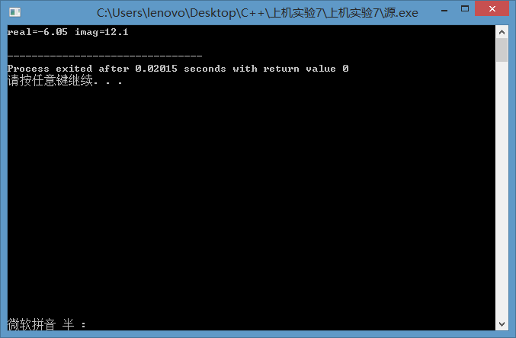

#include<iostream>

using namespace std;

class Complex {

public:

double real;

double imag;

Complex(double r = 0, double i = 0)

{

real = r; imag = i;

}

};

Complex operator*(Complex co1, Complex co2)

{

Complex temp;

temp.real = co1.real * co2.real - co1.imag * co2.imag;

temp.imag = co1.real * co2.imag + co2.real * co1.imag;

return temp;

}

int main()

{

Complex com1(1.1, 2.2), com2(3.3, 4.4), total;

total = operator*(com1, com2);

cout << "real=" << total.real << " " << "imag=" << total.imag << endl;

return 0;

}

心得：对一些已有的运算符进行“重载”操作，重新改造使之进行之前所不能完成的运算。